Detailed Teacher Instructions:
Inheritance, X-linkage, Evolution over Multiple Generations, Genetic Hitchhiking

Objectives:

Between the laboratory exercise and the associated lectures, students will be able to:
- Explain the process of evolution by natural selection in terms of fitness-related traits and allele frequencies
- Describe the concept of X-linked inheritance
- Perform DNA extractions, PCR, and gel electrophoresis
- Analyze molecular data as a means of understanding an evolutionary process
- Explain the concepts of selective sweeps, hitchhiking, and linkage

Materials:

- Drosophila melanogaster heat shock white-eyed strain 60739
- Drosophila melanogaster heat shock white-eyed strain 60740
- Drosophila melanogaster Zimbabwe (wild type) strain 60741
- Culture vials, plugs, and food (media) for Drosophila rearing
- Carolina Biological FlyNap® Anesthetic Kit: 173010
- (Optional but strongly preferred) CO₂ anesthetization facilities for Drosophila
- DNA extraction buffer and proteinase-K for DNA isolation
- Sorting brushes
- "Squishing buffer" and proteinase-K for DNA isolation
- Equipment and reagents for polymerase chain reaction
including oligonucleotides for "NEAR" and "FAR" markers
- Equipment and reagents for agarose gel electrophoresis
- Magnifying glasses
- Sharpie markers
- Custom PowerPoints and projector, if desired

This exercise allows students to view evolution over multiple generations, experiment with molecular techniques, and learn concepts of molecular evolution. This exercise requires considerable advance preparation (must be started approximately 6 weeks before planned class start date, with initial white-eyed fly crosses starting approximately 4 weeks before the planned class start date). The supplies and directions are listed out so that you may purchase or use supplies you already have. Kits are available at Carolina Biological Supply and eliminate the necessity of making many of the solutions needed. If you order a kit, follow the directions associated with it. Before beginning, it may be helpful to view the following educational videos on fly culture if you are unfamiliar with handling Drosophila (http://www.carolina.com/teacher-resources/Video/how-to-care-for-drosophila-video/tr11211.tr) (http://www.carolina.com/teacher-resources/Video/how-to-observe-phenotypes-with-drosophila-melanogaster/tr11212.tr). You must have fly food media on hand before beginning. The Carolina Biological Supply dry food (Formula 4-24 Medium) is mixed with water in the culture vial as per the instructions that come with it. Be careful not to add too much water, as the flies will drown.

Fly strains used in this experiment can be ordered through Bloomington Drosophila Stock Center. This exercise requires variability in the DNA sequence of the white-eyed fly population, so you need two independently derived white-eyed strains (you must order both strains of white-eyed flies). This variability is most easily accomplished through a cross between the heat shock white-eyed strain 60739 and heat shock white-eyed strain 60740. The heat shock white-eyed strain 60739 has an Mi{ET1} transposable element inserted near the eye color locus on the X chromosome, and the heat shock white-eyed strain 60740 has an Mi{ET1} transposable element inserted on the opposite end of the X chromosome. These elements helped aid in the process of genetic marker development that the students will examine in the molecular technique portion of this lab. Likewise, the added heat shock lethal Y component that these stocks carry ensures the collection of virgin females following heat shock procedures.

The first teacher cross is between VIRGIN heat shock white-eyed 60739 females and heat shock white-eyed 60740 males. This cross is designed such that the X-chromosome marker allele at the NEAR locus from the 60740 strain (which is identical to the NEAR locus allele in the red-eyed fly) is least abundant in the original population and will show the greatest change. The second teacher cross involves the flies mating with their siblings, so the teacher merely has to flip the offspring of the first cross to a new vial without sexing or manipulation.

It is VERY IMPORTANT in the first teacher cross that the female flies be virgins (never mated to another fly) so that ample allelic variability at both the NEAR and FAR markers is maintained. If the female is not a virgin, then she will most likely bear progeny of white-eyed 60739 strain. It does not matter if the males are virgins or not. When one receives flies from the supply company, you typically receive a vial of adult flies and a vial of larvae. It is highly probable that the adult flies have already mated and are no longer virgins. Hence, you must wait for flies to begin emerging from the vial of larvae. The helpful facet about the heat shock white-eyed strains is that when exposed to higher temperatures during development, males will die before emerging, but females will be left unharmed. Thus, only females will emerge from their pupal cases, ensuring that all of the females you collect are virgins. However, you should double check that all adults are females in the vials you heat shock.

Heat Shock Instructions to Collect Virgin Females:

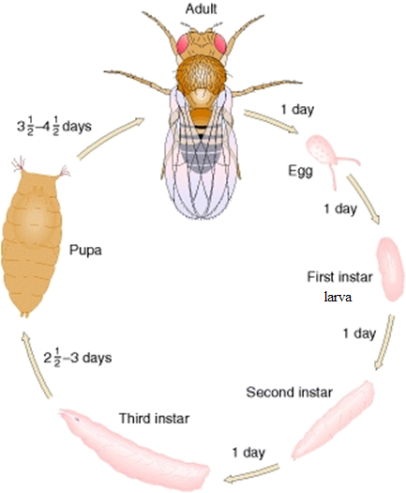
There are four major morphological changes that flies go through during the process of development: egg to larvae to pupae to adult (see diagram to the left). The heat shock treatment will only work when the flies are in the pupal stage. Once you start to see larvae crawling out of the food and encasing themselves in brown pupal cases, you should start the treatment. It will take a couple days for all of the larvae to become pupae, so you will have to repeat this treatment accordingly. Heat shock treatment consists of putting the vial of flies into an incubator set at 37°C (98.6°F) for one hour a day. These flies should be normally maintained at room temp (68-73°F) otherwise. You can do the heat shock treatment each day or every two days when you first start seeing pupae. Either method will suffice. Once adults begin to emerge, females can be collected until there are no more adults left in the vial and heat shock treatment continued until all females needed for the activity are collected. This treatment will not harm the larvae. HINT: when the pupal cases start to turn dark in color (almost black), this indicates that the flies are close to emerging. It takes approximately 10-11 days for D. melanogaster offspring to go from eggs to adults at room temperature. If it is colder in your classroom, this may take longer.

Reference pictures of larvae and pupae (indicated with red arrow):

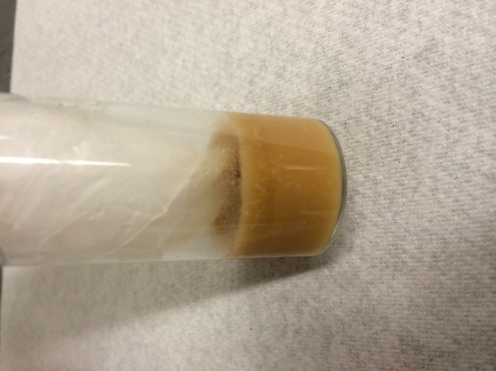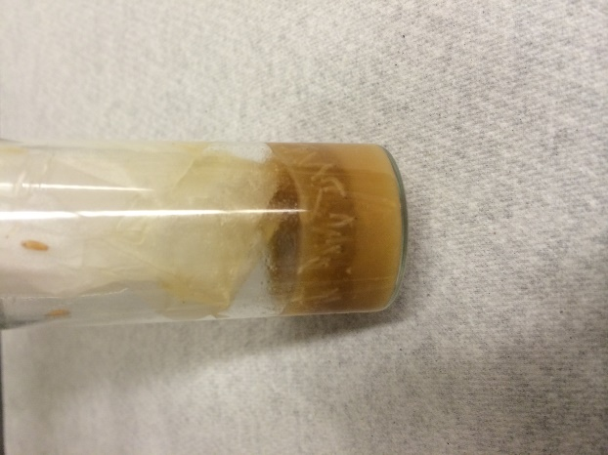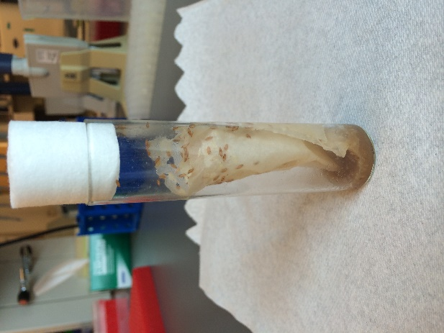
pupae
larvae
larvae

Collecting Flies and Sorting Them By Sex:

Though all of the flies in your heat shock vials should be females, you should double check to make sure that all of the live adults that emerge are female. You will also need to separate out males from females in your non-heat shock vials of white-eyed flies. Males typically have "black butts" whereas females have white, more pointed, abdomens (see Carolina Biological Drosophila manual for pictures). You should use the FlyNap anesthesia following the manufacturer's recommendations. However, it is highly recommended that you use CO₂ anesthetization here if possible, as too high of doses of FlyNap will kill your flies. It is easiest to sex flies when the flies are on their backs (wings against the table). To reduce mortality, it is important that the teacher minimize exposure of the flies to the FlyNap anesthesia: immediately removing the "wand" when the flies have become nearly motionless, and dumping the flies immediately onto a piece of paper for sorting. Even if the flies are moving a little, they are unlikely to fly away, so the teacher should immediately begin separating them, and not use the same plug that may have come in contact with the FlyNap anesthesia. If there is access to CO₂ anesthetization facilities for Drosophila, these can be used more safely than FlyNap, resulting in less fly mortality.

Females should be kept in a separate vial from males until it is time to cross them. It is best to collect more flies than what is needed to account for random fly mortality and any escapees as the students set up their crosses. Once collected, hold the males and females in the separate vials for at least 4-5 days to allow them to reach sexual maturity and mating receptivity. This makes the flies more likely to mate quickly when placed together for the students to see. Throughout this lab, you will only need to isolate flies for a 4-5 day period before setting up the Teacher Cross 1 (isolate virgin 60739 females and 60740 males) and before the Student Cross on Day 1 (isolate 4 virgin white-eyed females and 4 white-eyed males with 1 red-eyed male).

Female flies are like chickens and will lay eggs whether or not they are fertilized. Do not be alarmed if you see eggs in the food of vials you are holding your virgin females in. If you do not see larvae in the food, then the flies are probably virgins. Any flies you do not use can be killed by placing them in a fly “morgue” (a bottle filled with ethanol or oil). These should NOT be released back into the wild, as they contain an inserted genetic element.
NOTE: It is best if the males and females you use in the Teacher Cross 1 and by students on Day 1 are roughly the same age as each other, though 1-2 days of age difference will not harm the experiment.
Teacher In-Advance Preparation:

If all goes smoothly, this process takes about 4 weeks to complete from the time Teacher Cross 1 is set up. This includes the collection of the F2 white-eyed flies the students will use on Day 1 and the 4-5 day isolation period.

Teacher Cross 1:
Depending on the size of your class, you will want many replicate vials of crosses. You should attempt to set up at least 5 crosses (virgin 60739 females with 60740 males) per classroom (assuming 6-10 groups). You can accomplish this by either ordering more vials of each strain, or by perpetuating your own stocks. If you choose the latter option, you may simply allow brother-sister mating, and allow flies to remain in the same vial until larvae appear and the food media appears soupy. Instead of disposing of the adults, transfer them to a fresh vial and repeat. For this cross, you will want to heat shock the white-eyed 60739 fly stock to ensure that you get all virgin females, and leave the white-eyed 60740 fly stock at room temperature so that you can collect males. Be sure to isolate both the males and females for 4-5 days before setting up this cross. It may take 2+ weeks before this cross can be set up depending on if you decide to use larvae from vials sent to you from the company or perpetuate your own stock.

Teacher Cross 2 (~11 days later):
Once you have set up your first cross (~5 vials of 60739 females with 60740 males), flip the offspring of these crosses to fresh vials. Allow brother-sister mating to occur in these new vials (no virgins necessary). Expand the stock as stated above. It is ideal to start with 10 vials of this cross since you will need to heat shock some of these vials to collect virgin females, and leave the remaining vials at room temperature to ensure the emergence of males. On the day this cross is started, you should also place wild-type Zimbabwe 60741 adult flies into a fresh vial of food so that male red-eyed progeny you need to collect for the next cross will emerge on the same day as your white-eyed flies. Again, MAKE SURE you heat shock half of the vials of offspring from this cross, and leave the other half at room temp!

When the offspring of the second cross begin to emerge (~11 days later), you must once again separate males and females, and collect virgins. You should have enough for each pair or group to have one vial of four virgin white-eyed females and 1 vial of four white-eyed males with one red-eyed male. You may also wish to set up 2-3 control vials (or at least one per class) containing four white-eyed females and four white-eyed males. You will need to sex the wild-type Zimbabwe 60741 flies to obtain males (you do not need any females from this stock). You must obtain enough males to place 1 red-eyed male in each vial with 4 white-eyed males from the second cross. For each experimental group, you should now have a vial filled with four virgin females (white eyes) and a vial of four white-eyed males and one red-eyed male. If you do a control group you should have a vial filled with four white-eyed virgin females and one vial of four white-eyed males (no red-eyed fly). All of these vials should contain food media. Once all males and females are collected, hold them in their respective vials for at least 4-5 days before giving them to students. Note: It is recommended that you collect more males and females than needed for the experiment to account for potential fly deaths.

We recommend that the teacher set up two culture vials with fly food for each student group the day before the exercise (one for females and one for males). The dry food (Formula 4-24 Medium) is mixed with water in the culture vial as per the instructions that come with it. Be careful not to add too much water, as the flies will drown. By setting these up ahead of time, the students can put the adult flies together without applying the FlyNap anesthesia, and they are more likely to observe greater activity and mating success of the red-eyed male directly. In setting up, though, the teacher should not put the blue caps on the vials- they're a pain with no added gain at this stage.

Activity Instructions:

Day 1: Crossing the Flies and Observing

After a brief presentation about inheritance and natural selection, students are placed in pairs or groups and given two vials of flies- one with males and one with females. They should label their vials (preferably on label tape) with their names so students can get their own vials back the next day. Give students a chance to get familiar with how to tell apart males and females before setting up their crosses by showing a picture of males and females and describing that the males typically have "black butts" whereas the females have white, more pointed, abdomens. They are directed how to gently tap all the flies (but not the media) from one tube into the other. It's helpful if the teacher, teacher's aid, or someone with experience stand over the students when they do this. The procedure should be to tap the two vials upright simultaneously and gently on a book a couple times until all flies have fallen to the bottom of the vials, have the partner quickly pull both plugs off, gently tap on a book again to keep the flies at the bottom of the vials, and invert one vial such that the mouth of that vial is touching the mouth of the other vial. The students should tap gently until all males and females from both vials are in the same vial, and then quickly place the cap on the lower vial now housing all the flies. Common problems students encounter at this stage are:

1) panicking and freezing after the plugs are removed (at which point the flies start to fly out),
2) hitting the vials too hard on the surface, causing the media to fall from the upper vial into the lower vial (not a tragedy, but could potentially squish some flies), and
3) squishing some flies with the plug when putting it in the lower vial (again, not tragic).

Because of these common problems, and because this transfer of flies only takes a minute, we recommend that someone stand over the student groups as they do this and facilitate, rather than all the student groups doing this step simultaneously. Also, having extra vials of males and females on hand is a good precaution. If one of the white flies escapes or is squished, the exercise can still proceed, but if the red-eyed male is lost, then a substitute vial is needed.
After fly transfer, the students should put the vial down on its side on a white piece of paper, not manipulating it further, and be instructed to just watch the flies inside. Ask students to look specifically for any differences in activity of the red-eyed male over the white-eyed males. In many cases, students will observe courtship (such as the male extending one wing and vibrating it from behind the female) or even copulation. Typically, the red-eyed males will be the most active and most likely to mate given their better vision. In this regard, the red-eye gene variant (allele) can be thought of as a "beneficial mutation" in this experiment. At this point, the teacher can elect to show students online videos of fly courtship. (This can be shown before setting up the matings as well). Each species has a species specific “song” and dance that can be seen and heard in these videos:
- http://www.youtube.com/watch?v=KzWIuhXMUko
- https://sites.google.com/site/noorlabduke/courtship-songs
This can be used as a demonstration of sexual selection and animal behavior, as seen in many birds and mammals!
Teacher Note: When the offspring of this cross emerge, transfer them to new media and allow them to reproduce, though you should wait until there are at least ~20 flies (and clearly some of each sex) before this transfer. Female flies tend to emerge before male flies, so be vigilant. When the media appears "soupy" and there are many larvae present (usually 2-4 days), you can remove the adults and put them into fresh media to hand back to students on Day 2. You will need to label the vials with each transfer so students can be given the direct descendants of the original flies with which they worked. This is done to keep the multi-generational experiment perpetuating, as students may use too much FlyNap in Day 2 of the experiment, killing their adult flies.

Day 2: Generation 1

Students are given the offspring (generation 1) of the crosses they set up in Day 1. This is ~2 weeks after Day 1, though it might take longer depending on when you flip the offspring into new food to lay eggs before handing them back to students. You begin with a recap of the concepts of natural selection, what was done in the first day of the exercise, and ask the students to guess what they may observe in today's laboratory. The students anesthetize the flies using FlyNap and wait for them to be motionless for 2 minutes. VERY IMPORTANT: the vials should be left on their sides and not manipulated after the FlyNap wand is inserted. If the vial is placed standing up, the anesthetized flies will get their wings or bodies stuck in the food media and will be very difficult to take out of the vial. The wand can be left in for as long as needed and at higher doses if preferred: it's OK if the flies die as long as you have already generated offspring from them as described in the above teacher note. If some flies are still moving slightly, they will probably not fully wake up and fly around during the class exercise, so again, students should not panic.

On a white piece of paper, the students designate four quadrants as "white male", "white female", "red male", and "red female", and the flies are then poured onto the paper and sorted into the four categories. It's OK if some flies are left behind in the vial, so long as the majority of flies are poured out. The flies can be manipulated with a very fine paintbrush, pencil, or even with just the students' fingers. You can also give students a magnifying glass to help them determine the sex of the flies if they are having a hard time telling the difference between males and females.

Red ♂ | Red ♀
White ♂ | White ♀

Because of the X-chromosome linkage of the eye-color gene, none of the males will have red eyes. Check over the students' sexing of flies, as many will have invariably mis-sexed a few and identified putative red-eyed males. However, because of the greater mating success of the red-eyed male in the previous generation, many of the offspring females will have red eyes.

Occasionally, an experimental group vial will have all white-eyed flies. Rather than an "error", the teacher should use this example as instructive- ask the students why this may be an outlier. For example, while the red-eyed male may have had an advantage in vision and activity, he may have happened to be ill or unlucky in other respects unrelated to his genotype at the eye-color gene.

After the exercise is completed, the flies can be collected into a single vial and flushed down the toilet, placed in a fly morgue, or thrown away in the trash if the vial is capped. This can be done easily by creating a funnel out of a piece of paper and pouring them back into the vial. Most of them will be dead already given the heavier dose of anesthesia.

Fly Maintenance Between Days 2 And 3

You will need to flip flies into new media for a total of four (or three) generations, again, waiting until there are at least ~20 flies (and clearly some of each sex) and the media appears “soupy” with many larvae before you transfer. You will need to label the vials with each transfer so students can be given the direct descendants of the original flies with which they worked. Generation 4 adults should emerge ~5 weeks after the generation 1 offspring were put into fresh food and allowed to mate before being given to students on Day 2. This accounts for the 11-day life cycle of D. melanogaster. At the very end, the descendants of the original flies are returned to the students to observe the extent of change in abundance of the red-eye variant. About half of the flies will be red.

Day 3 – Evolution by Natural Selection and DNA Extraction

Teacher In-Advance Preparation

Below are instructions for preparing the solutions needed for the students’ DNA extractions.

- Prepare squishing buffer (SB):

10mM Tris-HCl, pH 8.2 100µl 1M Tris-HCl
1mM EDTA 20µl 0.5M EDTA
25mM NaCl 50µl 5M NaCl
Dilute to 9.9ml with dH₂O
This can be aliquoted and frozen for use.

2. Prepare Proteinase-K solution (Pro-K):

0.02g Proteinase-K (Sigma P-6556)
0.6ml 10mM Tris-HCl, pH 7.6
0.4ml glycerol
Store at -20°C.

While the individual SB and Pro-K solutions can be prepared in advance, making the master mix of the combined SB and Pro-K should only be completed just prior to class. Mix 49µl SB with 1µl proteinase-K solution per fly. Make a DNA extraction master mix by multiplying these proportions by how many flies your class plans to prepare (7 flies per group x the number of groups). From this DNA extraction master mix, aliquot approximately 350µl (50µl per fly) into small tubes (1-2 ml), one for each group. Place the DNA extraction master mix on ice.

Reference for protocol: Gloor GB, Engels WR (1992) Single-fly DNA preps for PCR. Drosoph. Inf. Serv. 71:148-149.

Materials for students
FlyNap
Students’ vial of generation 4 (or 3) flies
Magnifying glass
Tweezers
Sorting Brush
8-well Strip PCR tubes (1 per group)

Sharpie®
Bucket of ice
Cold (not frozen) squish buffer mixed with Proteinase-K
Pipettor
Pipettor tips
Thermal cycler

Student Instructions

Part 1: Evolution by Natural Selection
After 3-4 generations, the descendants of the original flies are returned to the students to observe the extent of change in abundance of red-eyed flies. Students should anesthetize their flies and dump them onto a piece of paper, as in the Day 2 activity described above. Students should record the number of flies in each category. Around half of the flies will be red.

Red-eyed Males | Red-eyed Females | White-eyed Males | White-eyed Females

The student pairs can compile their percentages on an excel sheet that can be shown to the class to see how evolution occurred in all of their classmates vials. If there was no natural selection, then 1/9 (11%) of all of the flies (including both male and female) should have had red eyes. Hence, the students have observed evolution by natural selection before their very eyes: the abundance of the red eye allele has changed! You then discusses evolution more broadly (it is merely "change through time, over generation(s)").

It is also useful to point out how evolution does not occur in exactly the same way (hence, different percentages in each vial), but will occur in a predictable way under the influence of natural selection (most, if not all, of the vials have over 11% red-eyed progeny). Occasionally, a vial will have all white-eyed flies. Rather than an "error", the teacher should use this example as instructive- ask the students why this may be an outlier. Evolution by natural selection will not proceed identically in every replicate because random events can happen. For example, while the red-eyed male may have had an advantage in vision and activity, he may have happened to be ill or unlucky in other respects unrelated to his genotype at the eye-color gene.

If a large proportion of vials have little to no red-eyed flies, it is likely that there was an error in the initial cross. This is not an ideal situation and is difficult to address. Reiterate that chance events can happen, and perhaps the red-eyed male in these vials escaped or died. Instead of focusing the class attention on these vials, focus on the few vials where students did see an increase in number of flies with red eye color.

Part2: DNA Extraction
After the exercise is completed, students will learn about how scientists use genetic markers that are variable in an organism’s genome (i.e. microsatellites, SNPs, etc.) to look for signs of evolution. They will then choose 7 male flies from their populations (following instructions below) to obtain DNA samples from. The rest of the flies can be collected into a single vial and flushed down the toilet, placed in a fly morgue, or thrown away in the trash if the vial is capped. If the students are not going to be setting up their PCRs that day, store the DNA preparations in the -20°C freezer until the next class.

1. Students must select 7 male flies to prepare for DNA Extraction. Students should select a representative sample of their flies (but make sure to include both white and red- eyed males).
- With tweezers or fingers, students should place one male fly into each well of the 8-well strip tube except one for a control, noting the eye color on the provided handout and on the top and sides of the tube with a fine-tipped Sharpie®.
- With a 100 or 200 μl pipettor, students should pick up 30 μl of the DNA Extraction Buffer solution and, without ejecting, stab the fly repeatedly with the pipettor tip. They can eject a small amount of liquid to help squish the fly. Remind them not to press too hard – the tube or tip can break! After the fly is squished (~20 seconds), instruct the students to eject the remaining liquid over the fly.
- Repeat for remaining flies, but be sure to change tips between flies- NEVER put a used tip back into the DNA extraction master mix solution. This will contaminate your DNA preps! Red-eyed flies will produce a pink colored liquid, white-eyed flies will remain colorless. The body of the fly should be visibly disassembled.
- Keep on ice until all preps are done. When all done, place in thermal cycler for 37°C for 30 minutes and 95°C for 2 minutes.

Questions for class discussion (with key):
What was the frequency of the “red-eye” mutation before the experiment?
The original frequency was 1/9 (11%) (one red-eyed male and 8 white-eyed males and females)

What is the frequency of the “red-eye” adults now in the experimental group?
This is dependent on your class data. In our experience, this has been roughly 45%.

What has happened? Why?
One expects to see an increase in the frequency of red-eyed flies. The most accepted definition of evolution is simply a change in allele frequency over time, and the class saw a change in the frequency of the red-eye allele, thereby witnessing evolution! The red-eye allele was advantageous because it allowed flies to see better, thus giving them a competitive advantage over their semi-blind white eyed neighbors. This allowed them to find mates quicker and live a healthier life.

Day 4 – Polymerase Chain Reaction (PCR)

This step can be combined with Day 3 activities if time allows (need ~2 hours). This step assumes that the teacher or instructor has some experience with PCR, and so does not go into detail regarding specifics not pertaining to this experiment. Today, students will conduct a PCR (Polymerase Chain Reaction) using each of our two primer combinations. These PCRs will amplify a particular segment- one pair amplifies a segment near the eye color gene, while another amplifies a segment far away, but on the same chromosome (the X chromosome).

Teacher In-Advance Preparation
To begin with, primers must be ordered from IDT (www.idtdna.com). The specifications for the primers are listed below. Once ordered, the primers take approximately 2 days for delivery, but order a week in advance to be safe.
- Navigate to http://www.idtdna.com/calc/analyzer.
- In the text box, enter in the sequence listed for each primer. (For example, for Dmel NEAR norm FWD1, enter “GTGCGGTTTCTGAGGTTCCC” into the text box).
- Click Analyze. It should show you the details of this primer (length and annealing temperature, etc.).
- Click “Add to Order.”
- Repeat for remaining primers. You should order a total of 5 primers:
Dmel NEAR norm FWD1, Dmel NEAR REV FM13, Dmel FAR FWD FM13,
Dmel FAR norm REV1, Mi{ET1} FWD2

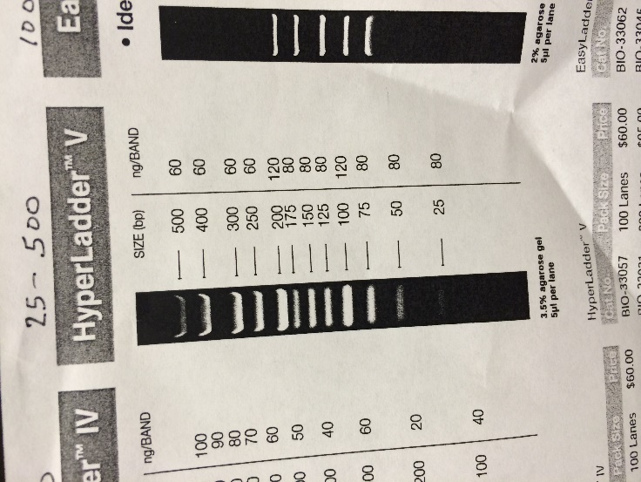
PCR products of these primer combinations are shown using HyperLadder V.

NEAR Primers
Primer triplet to show reduced diversity from sweep at marker near the eye color gene
Dmel NEAR norm FWD1: GTGCGGTTTCTGAGGTTCCC
Dmel NEAR REV FM13:CACGACGTTGTAAAACGACTGCTTGGCAAGTTTTGCGTGTAC
Mi{ET1} FWD2: CATGCTGTTCGAATTAATAGTGGTTGGGG

Extra information:
D. melanogaster genome position: 2,802,484 High allele fragment size: 162 bp
This is a gel showing genotypes of the parents of cross 1 (60739 female x 60740 male). The first four bands are the 60739 females, and they have the LOW allele. The last four bands are the 60740 males, and they have the HIGH allele. Note: wild-type Zimbabwe red-eyed flies before any crosses will have the HIGH allele.
low
high

FAR Primers
Primer triplet to NOT show reduced diversity from sweep at marker on other side of X chromosome:
Dmel FAR FWD FM13: CACGACGTTGTAAAACGACTCTCCCATTTACCTTGACTCGACTTTC
Dmel FAR norm REV1: ACACAATAATTGTTATCATCGACGTTGCCA
Mi{ET1} FWD2: CATGCTGTTCGAATTAATAGTGGTTGGGG
Extra information:
D. melanogaster genome position: 18,174,371 High allele fragment size: 160bp
This is a gel showing genotypes of the parents of cross 1 (60739 female x 60740 male). The first four bands are the 60739 females, and they have the HIGH allele. The last four bands are the 60740 males, and they have the LOW allele. Note: wild-type Zimbabwe red-eyed flies before any crosses will have the HIGH allele.
low
high
When you receive your primers, you must prepare them by finding the number of nm on the tube, multiplying this by two, and adding that many microliters of 1X TE buffer. This will give you a 0.5 mM primer concentration. For example, if you have 33.2 nm, add 66.4 µl of 1X TE buffer. (You may order 1X TE buffer, or prepare it yourself: 10 mM Tris, bring to pH 8.0 with HCl; 1 mM EDTA). Vortex the primer + TE solution thoroughly to mix, then microfuge it (if you have a microfuge available). Otherwise, shake it so that the liquid settles at bottom of tube. For your PCR, you will need to make a working stock of diluted primer for each primer (1:50 dilution to give you a 10 µM concentration). For every 1 µl of primer you use, you will add 49 µl of water. For example, to make 1 ml of diluted primer, add 20 µl of primer and 980 µl of dH2O to a labeled microcentrifuge tube (1-2 ml). Freeze both your original primer solution and your newly diluted primer solution at -20˚ C until ready to perform PCR, but remember, you will only use your diluted primer for the PCR.
The exercise proceeds most smoothly if the teacher prepares the two PCR master mixes in advance, though you can have students set this up themselves. Create a master mix for each primer combination below, adjusted for the number of flies plus extra for pipetting error. (For example, if you have 100 flies you would like to PCR, multiply each volume by 110. So 2 µl of buffer becomes 220 µl of buffer, etc.). Remove PCR buffer, dNTPs, and diluted primers from freezer and allow to thaw. Vortex each before using. Leave the Taq DNA polymerase in the freezer and add last. Vortex well to mix contents! If you fail to vortex, it is likely that the PCR will not work.

Note: One can add all ingredients except for the Taq DNA polymerase and freeze until use. Thaw and add the Taq DNA polymerase right before use (and vortex). Do not freeze master mix with Taq DNA polymerase; it will not work after this! Note: If you have trouble getting your samples to amplify, you can also try Phusion HF polymerase distributed by New England Biolabs (stock #M0530S).

Formula for PCR for Primer “NEAR Marker” (per reaction)
2 µl 10X PCR buffer (w/15-20 mM Mg⁺⁺)
2 µl 2 mM dNTPs
1 µl 10 µM Dmel NEAR norm FWD1 primer
1 µl 10 µM Dmel NEAR REV FM13 primer
1 µl 10 µM Mi{ET1} FWD2 primer
0.5 µl DNA polymerase
11.5 µl dH20

Formula for PCR for Primer “FAR Marker” (per reaction)
2 µl 10X PCR buffer (w/15-20 mM Mg⁺⁺)
2 µl 2 mM dNTPs
1 µl 10 µM Dmel FAR FWD FM13 primer
1 µl 10 µM Dmel FAR norm REV1 primer
1 µl 10 µM Mi{ET1} FWD2 primer
0.5 µl DNA polymerase
11.5 µl dH20

Directly before class, aliquot approximately 200 µl of DmelNEAR PCR master mix (with Taq DNA polymerase) (total volume of PCR master mix, 19 µl, multiplied by the number of reactions per group, 8, plus a lot extra for pipetting error) into labeled microcentrifuge tubes (1-2 ml tubes), one for each group. Repeat for DmelFAR PCR master mix. Put these on ice.

Materials for students

DNA extraction preps in strip tubes from last class
8-Strip PCR tubes (2 per group)

Sharpie®
Cold (not frozen) PCR Master mix for “NEAR” marker w/ polymerase added just beforehand
Cold (not frozen) PCR Master mix for “FAR” marker w/ polymerase added just beforehand
Pipettors (one that can pipette volumes of 1 µl, one that can pipette volumes of 19 µl)

Pipettor tips

Thermal cycler

Student Instructions
- Have students label each set of strip tubes. One set of strip tubes will be for the “NEAR” marker and one set will be for the “FAR” marker
- Vortex both tubes of master mixes
- Using a 20 µl pipettor, pipette 19 µl of PCR master mix for NEAR marker into each strip tube well for the NEAR marker. You can use the same tip for this step.
- Using a different tip, pipette 19 µl of PCR master mix for FAR marker into each strip tube well for FAR marker. Note if in this step or the preceding one whether you don’t have enough master mix. If that’s the case, then you may not have pipetted correctly. You can still fix it at this point, but call one of the teaching assistants over to look.
- Now you are ready to add your DNA! Using the 2 µl or 10 µl pipettor, pipette 1 µl of DNA from your DNA prep strip tubes to your master mix NEAR marker strip tubes. Important: Use a different tip for each fly prep! Close the lid after you add a fly prep to remind you which you have already done. Make sure you have labeled everything and know which fly is going into which strip tube well. Cap the tubes tightly afterwards.
- Repeat with the same flies into the master mix for FAR marker strip tubes.
- Now the strip tubes will be put in the thermal cycler. Program: Step 1: 1 x (95°C, 2 min), Step 2: 30 x (95°C, 30s; 60°C, 30s; 72°C, 1 min), Step 3: 4°C
- Refrigerate samples after thermal cycler is complete until ready to run on gels

Class discussion (with key)

What is the purpose of PCR?

The purpose of PCR is to amplify a target region of DNA for downstream analysis. It allows you to select a certain piece of the genome and copy it over and over so that you have enough DNA to analyze it in meaningful ways.

Day 5 – Gel Electrophoresis

Assemble equipment necessary for gel electrophoresis. During class, the students add their samples to a pre-made gel, run the gel, and analyze the results. Due to time constraints, the teacher should prepare the gels before class and the students can use class time to load and run gels.

Teacher In-Advance Preparation
The teacher should prepare one 1.8% LB agarose gel for each group.

Buffer

1X Lithium Borate (LB) Buffer
(Proprietary product of Faster Better Media LLC, 7 Blueleaf, Hunt Valley, MD 21030)

50 mL stock 20X LB buffer
950 mL deionized H₂0

This is mixed on a stir plate in a sterile, 1-L screw-cap bottle with a sterile stir-bar. Use fresh buffer each time a gel is run to obtain better resolution. For long-term storage, the buffer is filter-sterilized.

Gel (15 x 15cm)
100 ml 1X LB Buffer
1.8 grams Agarose
10 μl SYBR® Safe DNA Gel Stain (10,000X concentrate in DMSO – Invitrogen S33102)

Wear gloves whenever handling these reagents, gels, and/or gel equipment. Prepare a casting tray before beginning. Add agarose to a 500 mL flask then add 100 ml of 1X LB Buffer. Heat until large bubbles appear (this can be done with Bunsen burner or in a microwave). Use caution, as this easily boils over. You must watch the whole time and stop the microwave immediately if the mixture begins to rise in the flask. Remove from heat using a hot pad if it starts to bubble over, swirl, then return to heat. It is done when the liquid is clear and large bubbles appear. Add SYBR® Safe and swirl gently to mix. Cool for a couple minutes. Pour into casting tray, move any bubbles to the side using a pipette tip, add a 20-well comb, and let cool for 45 minutes. Cover gel with foil until the agar is set, as the SYBR® Safe is light sensitive. When agarose has set, remove comb and place casting tray in gel rig and cover with 1X LB Buffer. The gel is now ready to add samples. Again, cover gel rig with foil until ready for loading. Making the gels can be done several hours in advance of class as long as they are covered and not allowed to dry out.

100-bp Ladder-Loading Dye Solution (per well; one tube per group)
1 µl 100-bp Ladder
3 µl 6X Loading dye
14 µl 1X LB Buffer

A large volume can be made in advance (depending on the number of groups), aliquoted into labeled microcentrifuge tubes, and stored at -20°C until needed. Each tube should contain 18 µl of ladder-dye loading solution.

Optional: You may wish to have students practice their gel loading skills with loading dye and a small petri dish filled with agarose and a couple wells before loading their DNA. If this is the case, you will need to prepare the petri dishes beforehand. Add water to cover the gel in the petri dish to simulate the loading of the actual gel as accurately as possible.

Student Materials

PCR strip tubes from last class
Gel electrophoresis equipment
6X Loading dye
100-bp Ladder-Loading dye solution

Pipettor

Pipettor tips

Gloves

Student Instructions
- Students put on gloves.
- Prepare samples by adding 4 µl of 6X loading dye into each well of strip tubes. Close the caps and tap gently to mix. You should now have 24 µl of sample in each well.
- Add 18 µl of the 100-bp ladder-loading dye into one well. Carefully add 20 µl of each sample from strip tubes into the remaining individual wells of your gel. Label the placement of each sample on the worksheet (it is very important to keep track of which sample went into which well).
- PCR samples for both markers should be run for 45 minutes at 300 V.
- Gels can be visualized using a Gel Doc station with UV light. Alternatively, one can use a stain per manufacturer instructions.
Optional: You can substitute a 3% TBE agarose gel made with 1X TBE buffer and run for one hour at 160-170V if desired.

Day 6 – Analysis of results

Have students look at their gel printouts and answer the following six questions as a class. Additional questions are provided in the student handouts.

- Calculate the overall fractions of “high” vs. “low” at the NEAR marker (don’t worry about eye color now). Why did it change (or not)?

In the experimental group (see example generation 4 male gels below), there are 32/56 (57.1%) high alleles and 24/56 (42.9%) low alleles at the NEAR marker. The students should see an increase in the high allele frequency. If you genotype control samples, you should see that marker frequencies remain similar to starting allele frequencies.

- Calculate the overall fractions of “high” vs. “low” at the FAR marker (don’t worry about eye color now)? Why did it change (or not or not as much)?

In the experimental group (see example generation 4 male gels below), there are 45/56 (80.3%) high alleles and 11/56 (19.6%) low alleles at the FAR marker. If you genotype control samples, you should see that both the experimental and control samples have roughly similar allele frequencies.

- Now repeat questions Questions 2-3, but this time noting eye color.

Red-eyed flies | White-eyed flies
*NEAR High: 100% | *NEAR High: 14.3%
NEAR Low: 0 % | NEAR Low: 85.7%
*FAR High: 85.7% | *FAR High: 75%
FAR Low: 14.3% | FAR Low: 25%
- Is one allele “associated” with the red-eyed phenotype at NEAR? How about at FAR?

At the NEAR marker, one should expect to see an association of the high allele, as the red-eyed male added at the beginning had this variant. As the red eye trait spread through the population (selective sweep), the neutral variation nearby “hitchhiked” along with the eye color gene. More explicitly, the high allele hitchhiked with the red eye color. At the FAR marker, there should be random association. This is because the FAR marker is located at a distance from the red eye allele and can be disassociated with eye color over time through the process of recombination.

- What has happened overall in this demonstration?

Overall, we saw evolution by natural selection (change in allele frequency over time, or even just change over time). We introduced an advantageous mutation (red eye color) into a population of white-eyed flies. Because the red-eyed male had a fitness advantage, he was able to mate more and pass on his genes to the next generation. Over four generations, this resulted in an increase of the number of red-eyed flies in the population. At the molecular level, we witnessed the molecular evolution phenomenon of a selective sweep and the hitchhiking of a linked neutral variant near the eye color locus.

- Explain the process that occurred in your populations with respect to the eye color mutation, the near marker, and the far marker.

In the control population set up by the teacher, we started with all white-eyed flies and ended with all white-eyed flies. In the experimental population, we started with 4 white-eyed females, 4 white-eyed males, and 1 red-eyed male. At the end of four generations, we saw an increase in the proportion of flies that had red eyes (of both sexes). All of the red-eyed flies had the high allele at the NEAR marker since it was linked to the eye color gene and hitchhiked along during the process of selection. This is referred to as a selective sweep: the loss of variability in markers surrounding a selected variant, and would be most evident after many more generations when all the flies are red and there is no remaining variability at NEAR. The white-eyed flies still have variability at the NEAR marker (have both the high and low alleles), and both the red and white-eyed flies have variability at the FAR marker (have both the high and low alleles) since it is far away on the chromosome. The FAR marker is not linked to the eye color gene, and is therefore separated by recombination and not as strongly affected by the selection taking place at the eye color locus.

EXAMPLE DATA:
The initial allele frequencies of the parents used in the cross set up on Day 1 were calculated experimentally, but could also be calculated simply by knowing which strains carried which alleles in the initial cross. The teacher should use these values for comparison with the students’ data. The asterisks indicate the allele that the red-eyed fly from Day 1 carried at the NEAR and FAR marker (High at NEAR, High at FAR).

Starting Allele Frequency Data
*NEAR High: 26.9%
NEAR Low: 67.9%
*FAR High: 70.5%
FAR Low: 29.5%

*The following gels were run on a 3% TBE agarose gel using 1X TBE buffer and EtBr

White-Eyed Generation 4 Males at NEAR Marker

Red-Eyed Generation 4 Males at NEAR Marker (all have the high allele)

White-Eyed Generation 4 Males at FAR Marker
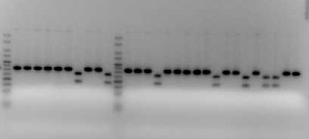

Red-Eyed Generation 4 Males at FAR Marker
Experimental Far Marker
Control Far Marker

